Norfolk County Council proposes to make a Temporary Traffic Regulation Order (the “Order”) (STRO14378) affecting the C776 Mere Road from 900 metres southeast of its junction with C132 Road from Watton Road to Rayners Falgate for 50 metres south-eastwards (the “Road”) in the Parish of Stow Bedon and Breckles to facilitate stop tap replacement works, the Road will be temporarily closed (except for pedestrian access) for the duration of the works/period the closure is necessary which is anticipated to be from 15th to 17th June 2026, but may continue to be closed/restricted until the 29th July 2026 where the closure is still required beyond the anticipated dates.

Alternative route is via: C776 Mere Road, C132 Road From Watton Road To Rayners Falgate, B1111 Watton Road, C130 Rockland Road/ Brayes Lane, U33028 Mere Road (Rocklands, Stow Bedon and Breckles).

The works promoter for this restriction/closure is: Anglian Water.

Vehicular access will be permitted to a final destination in the Road where signs indicating such access is possible and permitted are in place.

The Order shall automatically revoke on the completion of the works when the closure is no longer necessary or otherwise on the 29th July 2026 without further notice.

If necessary, the restriction could run for a maximum period of 18 months from the date the Order is effective.

A person who contravenes, or who uses or permits the use of a vehicle in contravention of the closure imposed by the Order shall be guilty of an offence.

Penalty: £1000 maximum fine on conviction and/or endorsement for contravention.

In the event of the start date being delayed the new start date will be displayed on site in advance.

Full details on the closure are available at https://one.network. Any enquiries that cannot be answered on the one.network website should be directed to the South Area Streetworks (Infrastructure Department) contactable by telephone at 0344 800 8020 or email at streetworks@norfolk.gov.uk

Dated this 5th day of June 2026.

Katrina Hulatt
Director of Legal Services (nplaw)
County Hall
Martineau Lane
Norwich
NR1 2DH

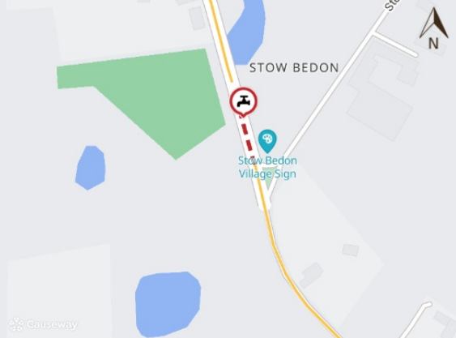

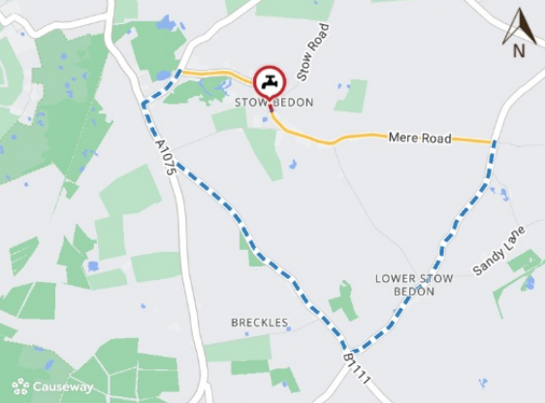

Imagery © 2026 MapTiler | Imagery © 2026 Hexagon | © MapTiler © OpenStreetMap contributors

